**Computer Networks Lab**

**Windows commands related to network configuration, management, and troubleshooting:**

1. **ipconfig**: Displays the current TCP/IP network configuration values.
   * Usage: ipconfig

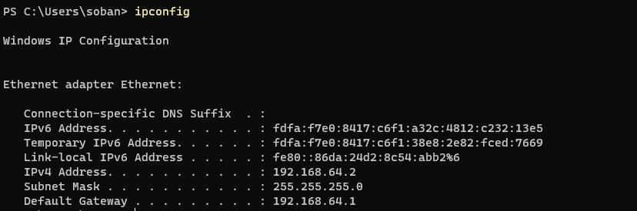

1. **ipconfig /all**: Displays detailed TCP/IP configuration information for all adapters.
   * Usage: ipconfig /all

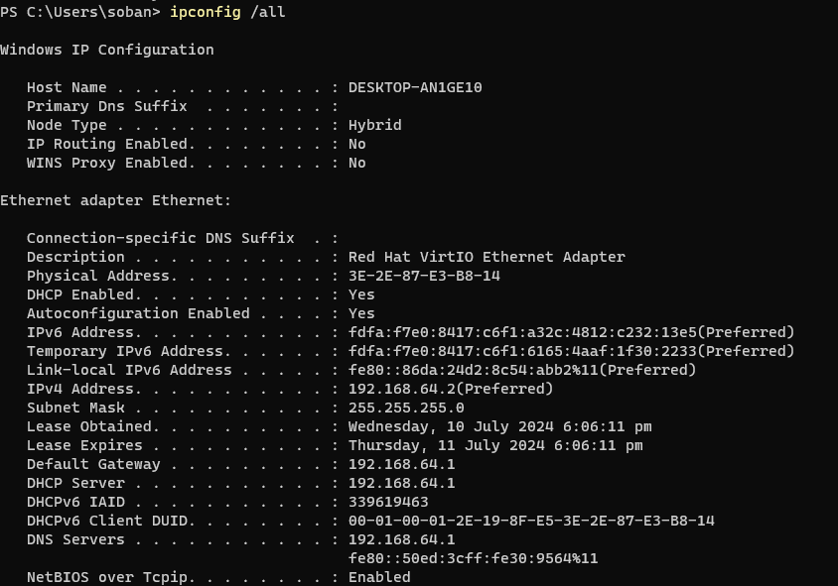

1. **ipconfig /release**: Releases the current DHCP lease.
   * Usage: ipconfig /release

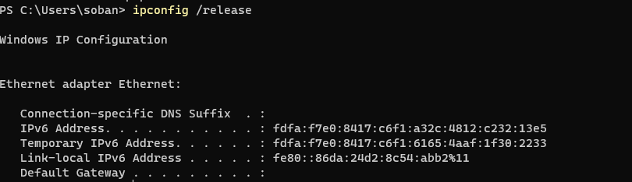

1. **ipconfig /renew**: Renews the DHCP lease.
   * Usage: ipconfig /renew

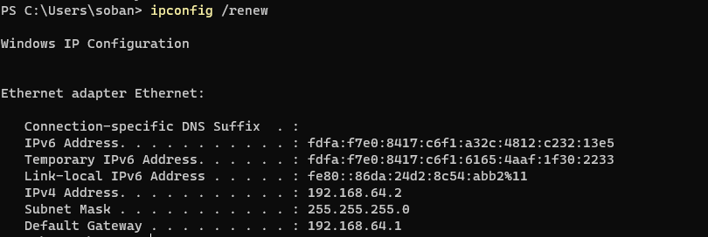

1. **ping**: Tests the connectivity to a specific IP address or hostname.
   * Usage: ping www.google.com 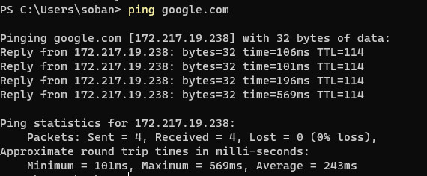
2. **tracert**: Traces the route packets take to a specific IP address or hostname.

# o Usage: tracert www.google.com

1. **netstat**: Displays active TCP connections, ports on which the computer is listening, and other network statistics.
   * Usage: netstat 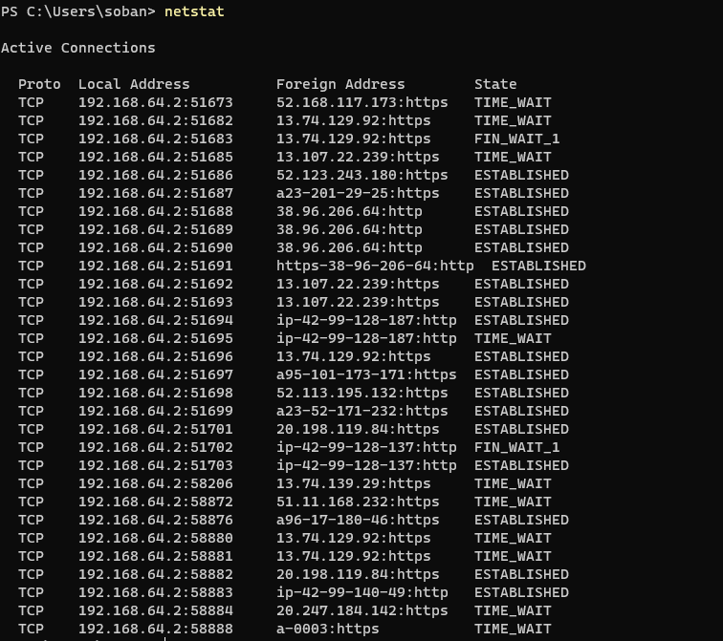
2. **netstat -an**: Displays all active connections and listening ports in numerical form.
   * Usage: netstat -an

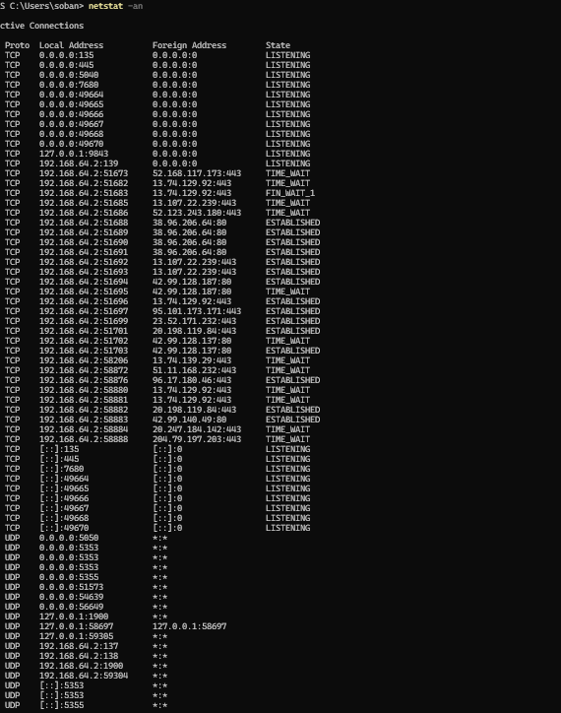

1. **nslookup**: Queries DNS servers for domain name or IP address information.

# Usage: nslookup [www.google.com](http://www.google.com)

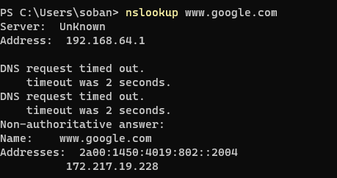

1. **arp -a**: Displays the ARP cache, which contains mappings of IP addresses to MAC addresses.
   * Usage: arp -a

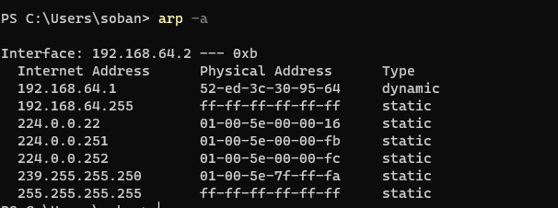

1. **route print**: Displays the routing table.
   * Usage: route print

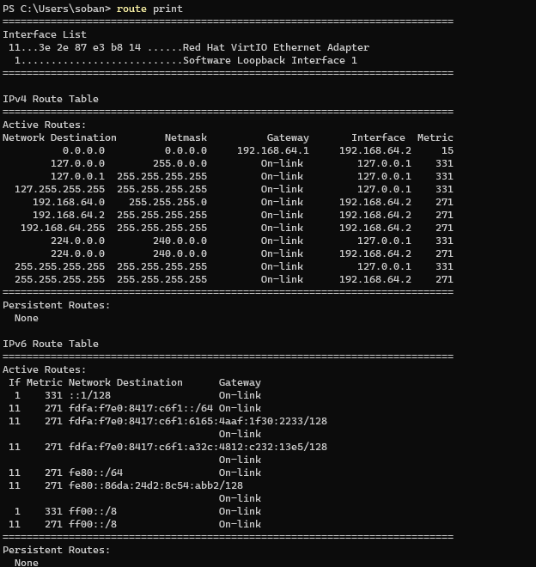

1. **route add**: Adds a new route to the routing table.

# Usage: route add 192.168.2.0 mask 255.255.255.0 192.168.1.1

# 

1. **netsh**: A versatile command-line scripting utility that allows you to display or modify the network configuration of a computer currently running.
   * Usage: netsh interface ip show config

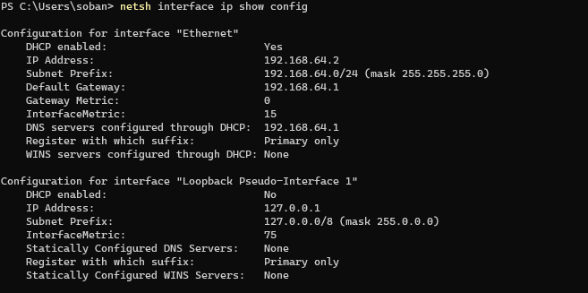

1. **netsh wlan show profiles**: Displays a list of wireless profiles saved on the computer.
   * Usage: netsh wlan show profiles



1. **netsh interface ip set address**: Configures the IP address for a network interface.
   * Usage: netsh interface ip set address name="Ethernet" static 192.168.1.100 255.255.255.0 192.168.1.1



1. **netsh interface ip set dns**: Configures the DNS server for a network interface.

# Usage: netsh interface ip set dns name="Ethernet" static 8.8.8.8

# 

1. **net use**: Connects or disconnects a computer from a shared resource or displays information about computer connections.

* Usage: net use Z: \\servername\sharename

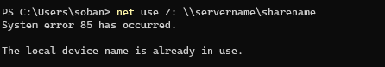

1. **net user**: Displays user account information and allows for user account management.

# Usage: net user

# 

1. **nbtstat**: Displays protocol statistics and current TCP/IP connections using NBT (NetBIOS over TCP/IP).
   * Usage: nbtstat -a <hostname>

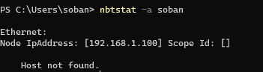

1. **Get-NetAdapter** (PowerShell): Gets the network adapter configuration of the computer.
   * Usage: Get-NetAdapter

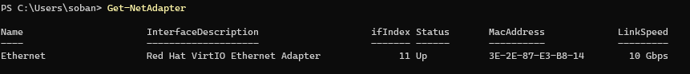

1. **ipconfig /flushdns**: Flushes the DNS resolver cache.
   * Usage: ipconfig /flushdns

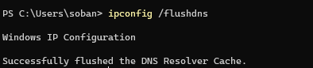

1. **ipconfig /displaydns**: Displays the contents of the DNS resolver cache.
   * Usage: ipconfig /displaydns 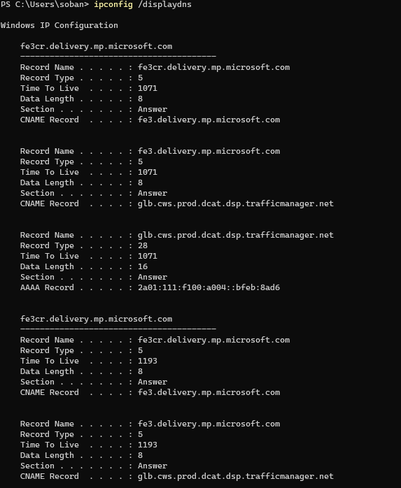
2. **ping -t**: Continuously pings a specific IP address or hostname until stopped.
   * Usage: ping -t www.google.com 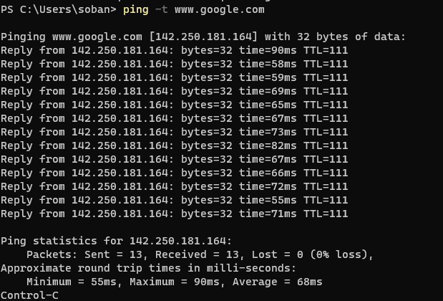
3. **ping -l**: Sends a ping request with a specified buffer size.

# o Usage: ping -l 1024 www.google.com

1. **pathping**: Combines the functionality of ping and tracert to provide information about network latency and packet loss.
   * Usage: pathping www.google.com 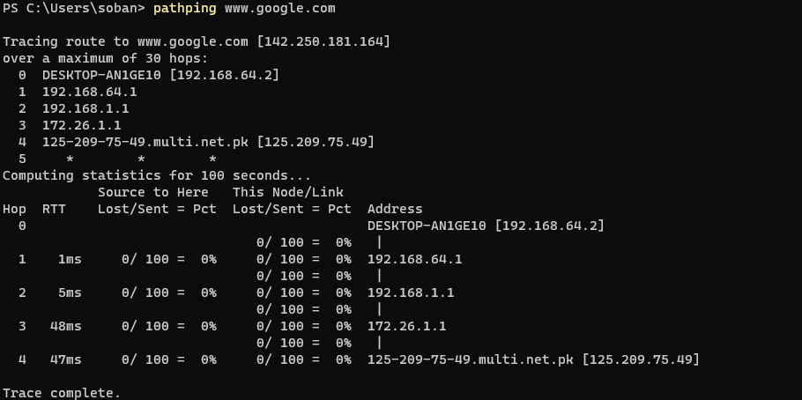
2. **net view**: Displays a list of network resources or computers.
   * Usage: net view \\servername 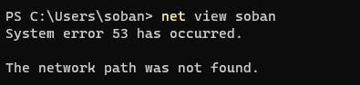
3. **net use \ip_address\sharename**: Maps a network drive using the IP address of the server.
   * Usage: net use Z: \\192.168.1.10\sharename 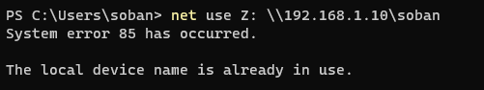
4. **net share**: Displays or manages shared resources.
   * Usage: net share sharename=C:\path\to\folder 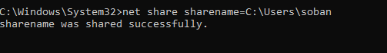
5. **net start**: Starts a network service.
   * Usage: net start servicename 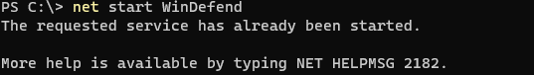
6. **net stop**: Stops a network service.
   * Usage: net stop servicename
   * I explicitly did this on purpose, because the I did not want to stop the windows defender feature.
   * 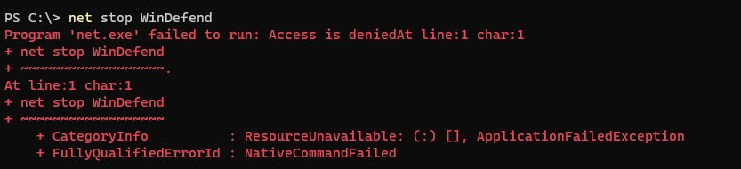
7. **telnet**: Connects to remote computers using the Telnet protocol.
   * Usage: telnet hostname port
   * The error message “The term ‘telnet’ is not recognized as the name of a cmdlet, function, script file, or operable program” indicates that the Telnet client is not installed on my system.
   * 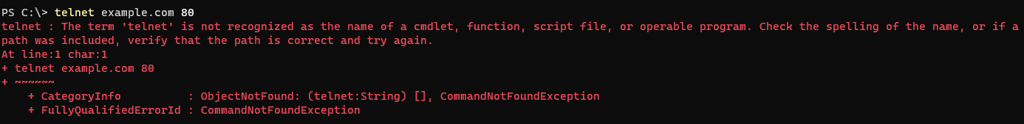
8. **ftp**: Transfers files to and from a remote computer running an FTP server.
   * Usage: ftp hostname
   * 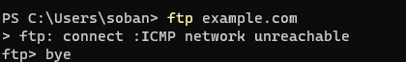
9. **Get-NetIPAddress** (PowerShell): Retrieves the IP address configuration.
   * Usage: Get-NetIPAddress
   * 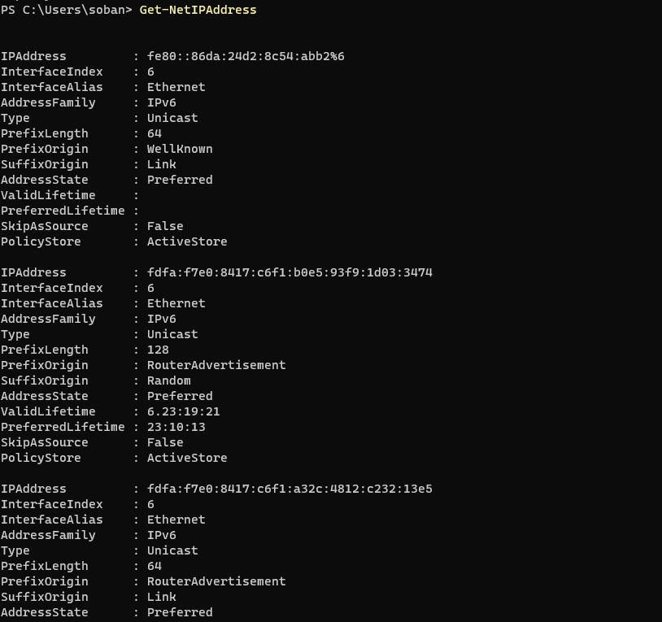
10. **Get-NetRoute** (PowerShell): Retrieves the IP routing table.
    * Usage: Get-NetRoute 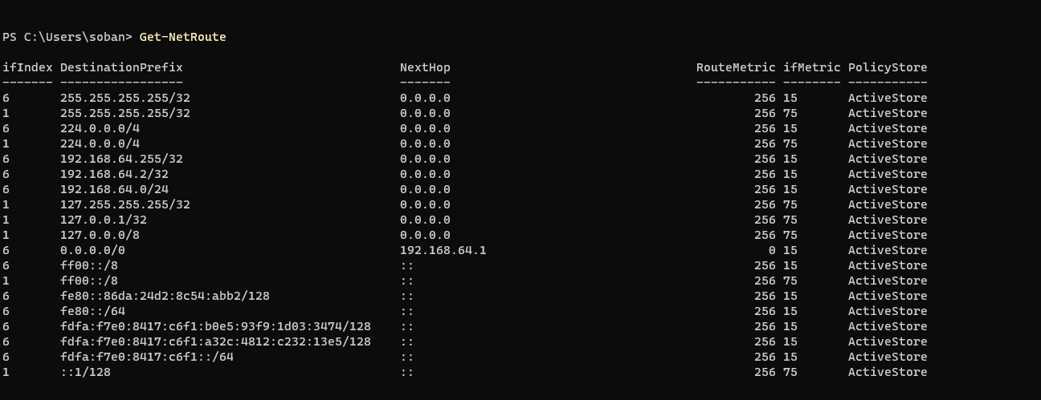
11. **Set-DnsClientServerAddress** (PowerShell): Configures the DNS server addresses.
    * Usage: Set-DnsClientServerAddress -InterfaceAlias "Ethernet" -ServerAddresses ("8.8.8.8","8.8.4.4") 
12. **Get-DnsClientCache** (PowerShell): Retrieves the contents of the DNS client cache.
    * Usage: Get-DnsClientCache 
13. **Get-NetAdapterStatistics** (PowerShell): Displays traffic statistics for network adapters.

# o Usage: Get-NetAdapterStatistics

1. **Test-Connection** (PowerShell): Sends ICMP echo request packets (pings) to test network connectivity.
   * Usage: Test-Connection -ComputerName www.google.com 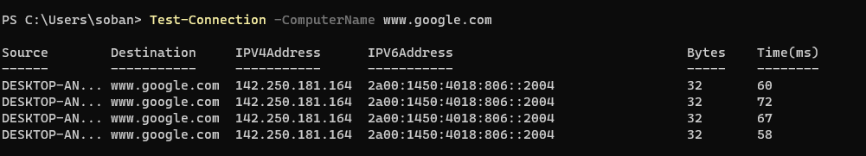
2. **Enable-NetAdapter** (PowerShell): Enables a network adapter.
   * Usage: Enable-NetAdapter -Name "Ethernet" 
3. **Disable-NetAdapter** (PowerShell): Disables a network adapter.

# o Usage: Disable-NetAdapter -Name "Ethernet"

1. **Get-NetFirewallProfile** (PowerShell): Retrieves the configuration of the Windows Firewall profiles.
   * Usage: Get-NetFirewallProfile 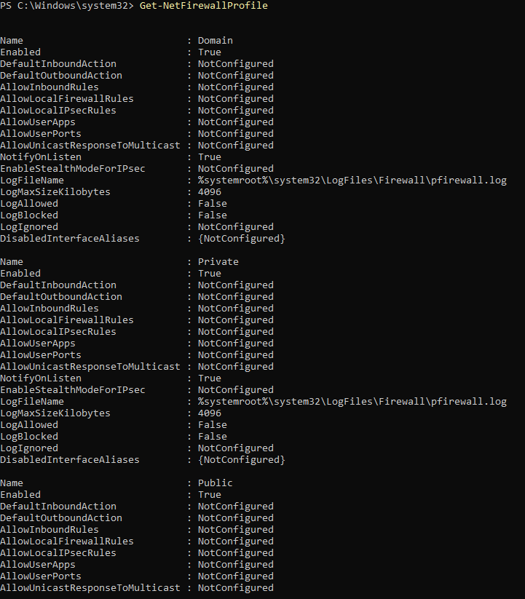
2. **Set-NetFirewallProfile** (PowerShell): Configures the Windows Firewall profiles.
   * Usage: Set-NetFirewallProfile -Profile Domain,Public,Private -Enabled False 
3. **Get-NetConnectionProfile** (PowerShell): Displays the network connection profile.
   * Usage: Get-NetConnectionProfile 
4. **New-NetIPAddress** (PowerShell): Configures a new IP address.

The error "Element not found" typically occurs when the specified interface alias does not exist on the system.



* + Usage: New-NetIPAddress -InterfaceAlias "Ethernet" -IPAddress 192.168.1.100 -PrefixLength 24 -DefaultGateway 192.168.1.1

1. **net statistics workstation**: Displays statistics about the workstation service.
   * Usage: net statistics workstation 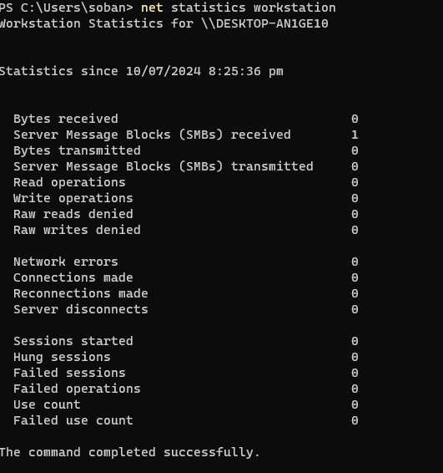
2. **net statistics server**: Displays statistics about the server service.
   * Usage: net statistics server 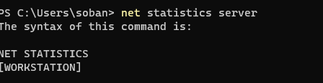
3. **Get-NetTCPConnection** (PowerShell): Retrieves active TCP connections.
   * Usage: Get-NetTCPConnection 
4. **Resolve-DnsName** (PowerShell): Resolves DNS names.

# Usage: Resolve-DnsName www.google.com

# The error "Element not found" typically occurs when the specified interface alias does not exist on the system.

# 

49. **Get-NetIPConfiguration** (PowerShell): Displays the IP configuration for all network interfaces.

# o Usage: Get-NetIPConfiguration

50. **Get-NetIPAddress -InterfaceAlias** (PowerShell): Displays IP addresses for a specific network interface.

# o Usage: Get-NetIPAddress -InterfaceAlias "Ethernet"

The error "Element not found" typically occurs when the specified interface alias does not exist on the system.

# 

1. **Invoke-WebRequest** (PowerShell): Sends HTTP and HTTPS requests to a web page or web service.

The error "Element not found" typically occurs when the specified interface alias does not exist on the system.



* Usage: Invoke-WebRequest -Uri <http://www.google.com>

I am unable the get a proper answer for it.

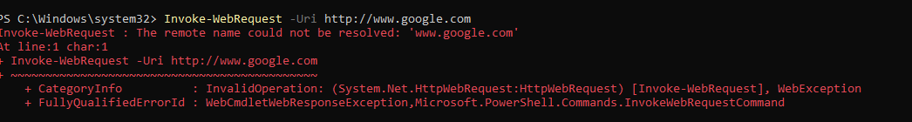

1. **netsh wlan connect**: Connects to a wireless network.
   * Usage: netsh wlan connect name="NetworkName"
   * 
2. **netsh wlan disconnect**: Disconnects from a wireless network.
   * Usage: netsh wlan disconnect
   * 
3. **netsh wlan show interfaces**: Displays information about wireless interfaces.
   * Usage: netsh wlan show interfaces
   * 
4. **netsh advfirewall set allprofiles state**: Configures the state of the Windows Firewall.
   * Usage: netsh advfirewall set allprofiles state off
   * 
5. **Get-Help** (PowerShell): Displays help about PowerShell cmdlets and commands.
   * Usage: Get-Help Get-NetIPAddress
   * 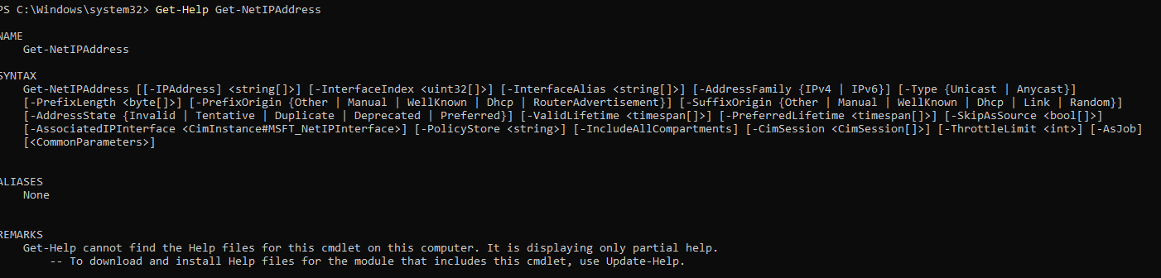
6. **net config**: Displays or configures a server service.
   * Usage: net config server
   * 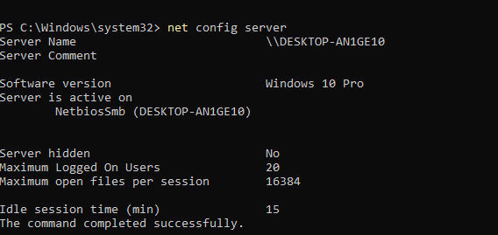
7. **ping -a**: Resolves addresses to hostnames.
   * Usage: ping -a 192.168.1.1
   * 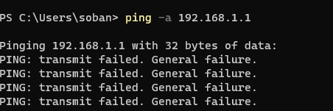
8. **netsh interface ipv4 show dns**: Displays DNS configuration for IPv4 interfaces.
   * Usage: netsh interface ipv4 show dns
   * 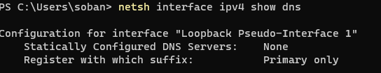
9. **Set-NetIPInterface** (PowerShell): Configures IP interface properties.

# Usage: Set-NetIPInterface -InterfaceAlias "Ethernet" -Dhcp Disabled

# The error "Element not found" typically occurs when the specified interface alias does not exist on the system.

# 